EXCALIBUR: THE LEGEND OF KING ARTHUR (PART ONE)
Written by: Tony Lee

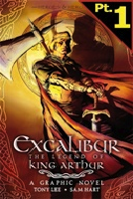

This lesson plan provides readers in Grades 7 - 12 with the opportunity to explore the classic story of King Arthur in graphic novel format. Part One specifically focuses on vocabulary and the story structure of myths, introducing the hero myth cycle.

Lesson Objectives:
To be able to read, comprehend and make sense of a classic myth using examples from the text
To be able to identify, explore and explain vocabulary related to story context
To be able to identify perspective in a myth

Grade Level: 7 - 12

Common Core Connections:
Meaning: Determine explicit text meaning using information, evidence and text quotes
Structure: Integrate and evaluate visuals to understand incidents/characters/settings, both implied and explicit
Language Convention/Clarity: use words, phrases, clauses and syntax to make sense of text
Knowledge Demands: multiple character perspectives, historical perspective

Strategies:
Students will be able to read, comprehend and make sense of a classic myth told in graphic novel format using visuals, explicit and implied text evidence and information
Students will be able to identify perspective in a narrative myth
Students will be able to expand vocabulary awareness in the context of a classic myth

Materials/Resources:
- EXCALIBUR: THE LEGEND OF KING ARTHUR (PART ONE) e-book on tumblebookcloud.com
- SMARTboard or other interactive white board (or projector/laptop)
- Laptops/iPads
- Dictionaries/online dictionaries
- Vocabulary organizer, Hero journey visual
- http://www.youtube.com/watch?v=8AG4rlGkCRU
- Writing journals

Strategic Lesson Plan:
- Introduce the graphic novel, EXCALIBUR: THE LEGEND OF KING ARTHUR (PART ONE on the Smartboard and discuss with students their background knowledge of this story using questions to promote higher order thinking
- Discuss with students their understanding of a ‘myth’ and a ‘hero’ encouraging them to consider modern myths and heroes – can include examples from movies, stories, current events, etc
- Display the ‘hero myth cycle’ on the Smartboard and show the brief YouTube clip describing the hero cycle – discuss and clarify, using questions
- Discuss with students this is the first of five parts of the story and will lay the foundation for the story – our work today is to begin building a framework for the myth; review the need to use visual clues, explicit information and implicit information at all times
- Today students will be introduced to three activities that will enhance comprehension and encourage making connections with the story:
  - Vocabulary Tracking Organizer
  - Character Tracking Organizer
  - Hero Myth Cycle Organizer
- Review the organizers and their purposes; ask students to complete them as they read/listen and reflect on the story
- Once students have their organizers on their laptops/tablets or in their journals and are logged into tumblebookcloud.com, they can begin engaging with the text in groups or independently, completing charts as appropriate
- Circulate while students are working, offering support as needed and encouraging students to provoke their thinking and understanding of the text
- Encourage students to record evidence, quotes, vocabulary on their organizers
- When students are finished their reading/listening experience, provide opportunities to share ideas and understandings from the story using ‘turn and talk’ strategies (5 – 10 minutes)
- As students share their questions and insights, encourage them to also share the data they are collecting on their organizers
- Complete what they can on the organizational charts (they are intended to carry the students through all five parts of the series)
- Share charts with each other and check back with the story to make sure information is accurate
- Additional Information:
  - These activities can be carried forward to the remaining four parts of the story

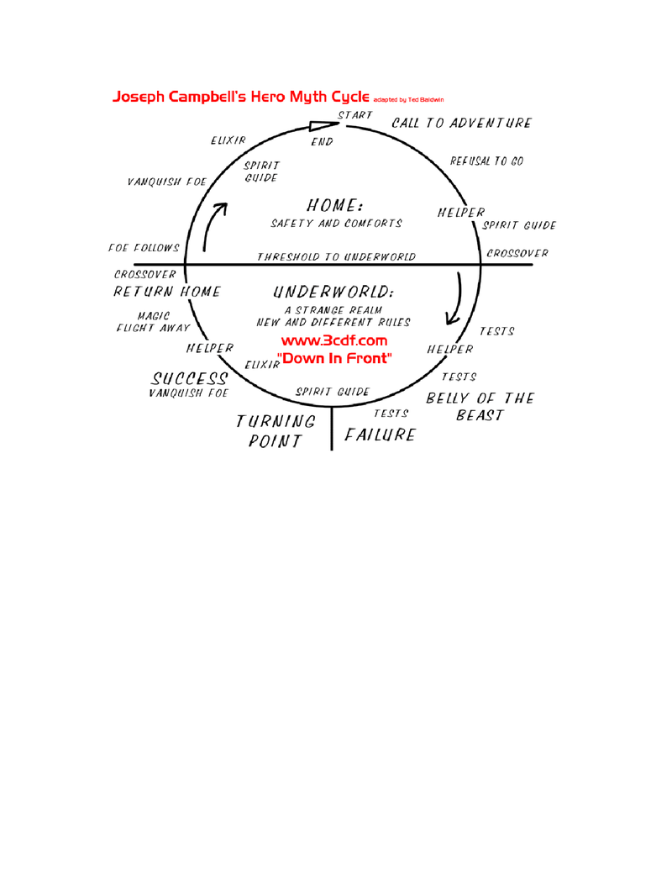

KEY VOCABULARY ORGANIZER
EXCALIBUR: THE LEGEND OF KING ARTHUR
WORD | PART OF  SPEECH | DEFINITION | TEXT EVIDENCE

HERO MYTH ORGANIZER
EXCALIBUR: THE LEGEND OF KING ARTHUR
Based on Joseph Campbell’s “The Hero with a Thousand Faces”

Hero Phases: | Text Evidence (summaries, pages, etc)
Call to Adventure:
Describe how the hero receives the call to adventure in an environment where he is not particularly comfortable

Refusal of the Call to Adventure:
Describe how the hero declines or dismisses the call to adventure and explain why (fear of change/failure/etc)

Overcoming the Refusal:
How the hero meets with a mentor to overcome his challenges/fears

Crossing the Threshold – Engaging the Adventure:
Describe how the hero begins the adventure

Test Allies and Enemies:
How does the hero decide who is his ally and who is his enemy

Experiment:
Describe how the hero experiments with his/her new world, what lessons, what is needed to succeed

Approach:
How is the hero demonstrating readiness to face the battle – this is the rehearsal stage – what does it look/sound like?

Facing the Test:
The hero engages, possibly facing death – what does this look like; how is the hero feeling

Reward:
Once the hero passes the first battle, there is a reward

The Road Back:
Describe how the hero collects himself and begins to bring closure – or establish a new beginning

Resurrection:
Describe how the hero faces the next great challenge and faces death once more – perhaps on a greater scale – what transformations have occurred

The Return:
Describe how the hero returns with the ‘elixir’ or the ‘golden moment’ – he has been on a journey and now returns to share his new knowledge or skills with others

